ALLIED SOFTBALL RULES
85
RULE 1: EQUIPMENT
SECTION A NECESSARY EQUIPMENT
- Only the foam champion ball may be used in practice or competition.
- Bats shall be of the soft, safety variety for indoor play.
- Batter/ base runners shall wear a NOCSAE-approved protective batting helmet with a commercially-manufactured face mask attached to it while on the field of play.
- Catchers shall be fully outfitted (helmet, mask, throat protector, chest protector, and shin guards) in approved softball protective gear when playing or practicing, as stated in the NFHS Rulebook.
- Gloves may be worn by all fielders (this means all players, including the pitcher and all assistants.)
- Bases shall be used in all practices and games. Bases shall consist of the rubber, "waffle bottom" style.
RULE 2: GENERAL RULES
SECTION A GAME PLAY
- A regulation game shall consist of seven innings. No new inning will begin after 1 hour 30 minutes of play.
- All rules of a regulation softball game apply.
- Pitchers must be a minimum of 30 feet and a maximum of 40 feet from the apex (back edge) of the plate.
- Two different bases shall be used to create "double bases" for all four bases on the gym floor. One base will be used by the fielders (the base closest to the pitcher's mound), while the other base will be used by the
base runner. The "runner's base" at first is positioned in foul territory. The "runner's base" at second and third is positioned behind the fielder's base on the outfield side of the base.
- On game days, the home team shall conduct an on field warm-up for a maximum of 15 minutes, followed by the visiting team for a maximum of 15 minutes. Teams may use less time to warm-up if they so desire. The game shall begin immediately following the completion of the warm-up period (no earlier than 3:15 pm).

6. Sites shall include team benches located a safe distance from the home plate area and a safe area(s) designated for spectators. Existing floor lines should be used as foul lines so that playing rules can be kept as similar to outdoor play as possible (see diagram of "field" set up for dimensions).
86
RULE 3: MODIFICATIONS
SECTION A TEAM
- Each playing field should consist of ten players. No games shall begin with less than seven players in the field.
- A team unable to field up to seven players on any scheduled game date shall forfeit to their opponent. Forfeited games cannot be rescheduled.
SECTION B BATTERS AND BASE RUNNERS
- All players may be placed into the team batting order, even if there is not a position in the field for them to play right away. A team's term at bat ends when five runs have scored or three outs have occurred within their half inning. This "5-run rule" shall remain in effect for the duration of each game.
- Runners may not steal or lead off.
- Runners may not slide.
- Batters may not bunt.
- Batters may elect to use a tee after two strikes. Players should be encouraged to bat without tees as much as possible.
- Batters can strike out.
- In the interest of speeding up play, courtesy runners may be used for any base runner, especially for the catcher when there are two outs (see NFHS rulebook). Since all players are technically in the game, the courtesy runner shall be the player who made the most recent out.
- Batters cannot be walked.
- When batting without the use of a tee, three strikes shall be an out.
- A batter with two strikes may elect to then use the tee. Once using the tee, two additional swings without hitting the ball will be allowed before considering the batter out on strikes.
- Batters who elect to use a tee are limited to a maximum hit of a ground-rule double.
- A foul ball is considered a strike.
- A player cannot strike out on a foul ball.

SECTION C FIELD PLAY
87
- A defensive player may not block a base.
- Adult coaches or highly skilled players should pitch.
- An adult pitcher cannot field a batted ball or throw to a base.
- A player must be designated to play in the pitcher's area if an adult is pitching.
- When an adult is pitching, the student player should be positioned in the vicinity of the pitcher's mound to field any balls batted into that area.
- An adult pitcher or player assistant does not count as one of them.
- Pitches should be slow, hittable, and have a noticeable arch.
- Fast, flat pitches are considered "no pitch."
Additional Fielding Rules for Indoor Play
- A batted ball hit directly against the wall, ceiling, or bleachers in fair territory is playable and if caught before it falls to the ground shall be called an out.
- If a batted ball hits the ceiling in fair territory and rolls into foul territory between home and first or home and third, it is a foul ball.
- A batted ball which becomes lodged anywhere in fair territory shall be considered a ground rule double.
- Home teams may determine an area on the back wall that will be considered an automatic home run when a ball is hit there (optional).
ALL OTHER GENERAL SOFTBALL RULES OF THE NFHS SHALL APPLY.

Automatic Changeover Rule 2014: Any team establishing a 10 run or more lead will automatically end their at bat after 3 scored runs (rather than 5) regardless of the number of outs. If the lead goes below 10, they may go back to 5 runs for an automatic changeover

BEGINNING IN THE 2016 SEASON RUN SPOTTING WAS ELIMINATED
ASSESSMENT IS FOR RESOURCE / EVALUATION USE ONLY

ALLIED SOFTBALL REQUIRED SKILL ASSESSMENT
RUN SPOTTING PROCEDURES
88
The following are guidelines to assist you in running competitive games during the season so that your student athletes have the most positive experience possible. The first step is to administer the skills assessment which will determine the strengths and weaknesses of individual players. This assessment will help determine the number of points a team will be spotted so that teams will be equally matched.
Administering Required Assessment Test/Scoring
- After five days of practice, all athletes will perform the Allied Softball Skill Assessment which is provided.
- Each athlete will complete an individualized score sheet.
Each athlete will be assessed in five areas: knowledge of the game, batting, throwing, catching, and timed run.
- Each athlete will be rated from 1-3 points in each area. The highest quantity to earn in each individual assessment is 3 points. The highest total of possible points earned is 15 points
- Each athlete's score will be compiled for a total team average.
- On game day, the team average should be computed for only those students actually playing in that particular day's game.
Exchanging Required Team Averages
Prior to the game, Team A has a team average of 13 points and Team B has a team average of 9.8 points. Team B's number will be rounded down to an actual point average equaling 9. The difference between the two team averages equal four points. Therefore, Team B will be spotted four runs.
Note: Teams will receive their spotted runs only after their team has scored the first run.

Name:
89
Total Points:
Softball Skills Rating Chart
Directions: After student-athletes have completed each skill, please circle the appropriate score.
- Knowledge of the Game: (see written assessment)
0 - 4 = 1pt 5 - 7 = 2pt 8 - 10 = 3pt
Fair Average Excellent
- Batting: student-athletes will attempt to hit the bill into fair territory. A total of 10 hits: 5 hits off the tee into fair territory, 5 hits from a live pitch into fair territory. Points are only scored when a batted ball passes the pitcher’s mound 30 feet away.
Note: Strikes should be counted in the total number. Please take into consideration the speed at which the ball travels. If the majority of kits are slow rollers past the pitcher’s mound the student should be scored "fair" to "average" and not "excellent".
0 - 4 = 1pt 5 - 7 = 2pt 8- 10 = 3pt
Fair Average Excellent
- Throwing: student-athletes will throw 10 balls from a distance of 40 feet into a designated square target. The target may be taped to the gymnasium wall and shall be 4' high by 4' wide.
0 - 4 = 1pt 5 - 7 = 2pt 8 - 10 = 3pt
Fair Average Excellent
- Catching: student-athletes will catch 10 balls from 20 feet away with no bounce.
0 - 4 = 1pt 5 - 7 = 2pt 8- 10 = 3pt
Fair Average Excellent
- Timed run: student-athletes will run to first base while being timed.
8 or more sec. = 1 pt. •5 - 7 = 2pt 0 - 4 = 3pt
Fair Average Excellent
Note: Student-athletes with 8 or more seconds are eligible to use the halfway "X" base in game play.

ALLIED SOFTBALL --- INDOOR FIELD SET-UP AND DIMENSIONS

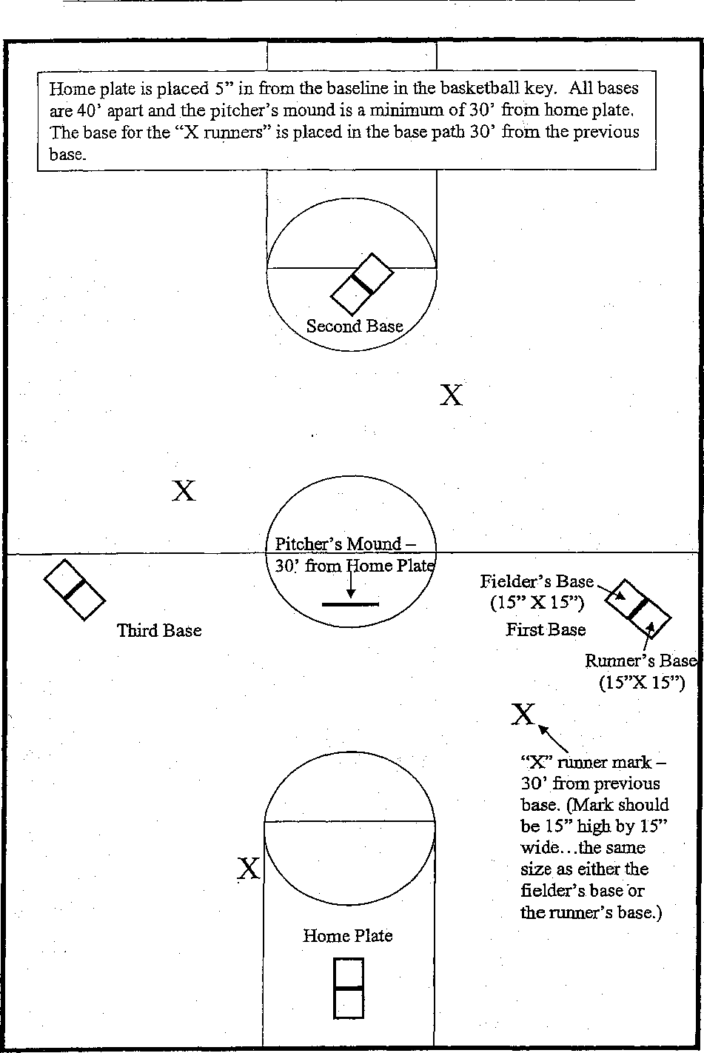
Home plate is placed 5" in from the baseline in the basketball key. All bases are 40' apart and the pitcher's mound is a minimum of 30' from home plate. The base for the "X runners" is placed in the base path 30' from the previous base.
Second Base
x
Pitcher's Mound —
Third Base
30' from home Plat
Fielder's Base (15" X 15")
First Base
Runner's Base (15"X 15")
Home Plate
/1111•••••••
"X" runner mark — 30' from previous base. (Mark should be 15" high by 15" wide...the same size as either the fielder's base or the runner's base.)
92

ALLIED SOFTBALL SCORESHEET
SCHOOL: AVERAGE:
OPPONENT:
AVERAGE:
DATE:
SPOTTED POINTS:

NAME | TEE | POSITION | 1 | 2 | 3 | 4 | 5 | 6 | 7 | NOTES
 |  |  |  |  |  |  |  |  | •
- ,

BALTIMORE COUNTY PUBLIC SCHOOLS OFFICE OF ATHLETICS
INTERSCHOLASTIC ATHLETIC SCORE REPORT
BOYS' / GIRLS' VARSITY / IV

(Sport) | (Circle One) | (Circle One)

vs.

(Visiting Team & Classification)
(Home Team & Classification)

 |  |  |  | LEAGUE / NON-LEAGUE / OTHER
Original Date of Contest) |  | Actual Date of Contest) (Circle One)

(Winning Team) (Score/Scores)
SCORE REPORTED BY:
ALL coaches MUST submit one copy of this form to their Athletic Director to be forwarded to the Office of Athletics immediately following ALL HOME LEAGUE games and ALL NON-LEAGUE tamest it I I
ALL coaches must also submit another copy of this form to their Region Tournament Director for ALL
GAMES!!!! •
BALTIMORE COUNTY PUBLIC SCHOOLS
OFFICE OF ATHLETICS
INTERSCHOLASTIC ATHLETIC SCORE REPORT

BOYS' / GIRLS'
(Sport)
(Circle One)
VARSITY / JV
(Circle One)

vs.
(Visiting Team & Classification) - (Home Team & Classification)
LEAGUE / NON-LEAGUE / OTHER

Original Date of Contest) | Actual Date of Contest) (Circle One)

(Winning Team) (Score/Scores)
95
CORE REPORTED BY:
ALL coaches MUST submit one copy of this form to their Athletic Director to be forwarded to the Office of Vthletics immediately following ALL HOME LEAGUE games and ALL NON-LEAGUE games!! I I I

